H.T No
Regulations:
A18

Sreenidhi Institute of Science and Technology
(An Autonomous Institution)
Code No: 7KC81 Date: 20-Mar-2021 (FN)

B.Tech III-Year I- Semester External Examination, March/April - 2021 (Regular)
STRUCTURAL ENGINEERING (CIVIL)

Time: 3 Hours Max.Marks:70

Note: a) No additional answer sheets will be provided.
b) All sub-parts of a question must be answered at one place only, otherwise it will not be valued.
c) Missing data can be assumed suitably.

ANSWER ANY 5 OUT OF 8 QUESTIONS. EACH QUESTION CARRIES 14 MARKS.

Bloom's Cognitive Levels of Learning (BCLL)

Remember | L1 | Apply | L3 | Evaluate | L5
Understand | L2 | Analyze | L4 | Create | L6

 |  |  | BCLL | CO(s) | Marks
1. |  | Determine the Static and Kinematic indeterminacy of the following truss.  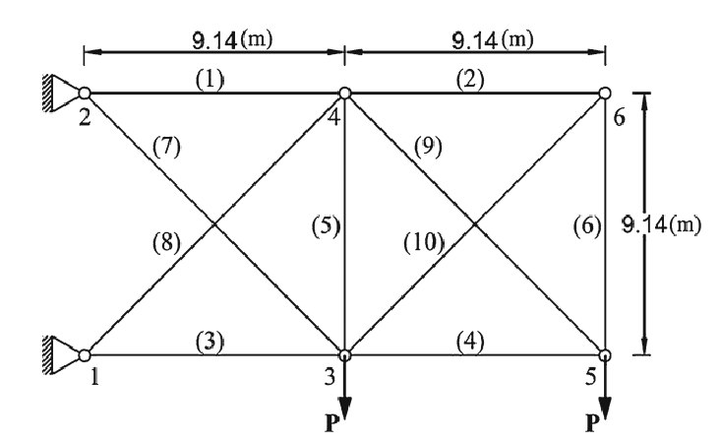 | L5 | CO1 | [14M]
2. |  | Determine the fixed end moments developed by the beam.  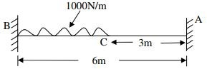 | L5 | CO2 | [14M]
3. |  | A continuous beam ABC is fixed at A and simply supported at B and C. The span AB is 6m and carries a uniformly distributed load of 20 kN/m. The span BC is 6m and carries uniformly distributed load of 30 kN/m. Determine the fixed end moments by Slope Deflection method. | L5 | CO3 | [14M]
4. |  | A continuous beam ABC of constant moment of inertia is simply supported at A .The beam carries a central point load of 4kN and clockwise central couple of moment 30kN-m in span BC as shown in the figure. Find final end moments.  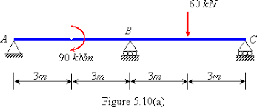 | L5 | CO4 | [14M]
5. |  | A continuous beam ABC is fixed at A and simply supported at B and C. The span AB is 6m and carries a uniformly distributed load of 15 kN/m. The span BC is 4m and carries a point load of 30 kN. At centre Determine the fixed end moments by Slope Deflection method. | L5 | CO5 | [14M]
6. |  | Analyze the following truss.  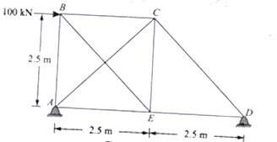 | L4 | CO6 | [14M]
7. | a) | A continuous beam ABC is fixed at A and C,simply supported at B Determine the Static indeterminacy. | L5 | CO1 | [5M]
 | b) | Write the static indeterminacy of propped cantilever and fixed beam. | L1 | CO2 | [5M]
 | c) | Write the Slope- Deflection equation. | L1 | CO3 | [4M]
8. | a) | A continuous beam ABC is fixed at A and C, simply supported at B Determine the Kinematic indeterminacy. | L5 | CO4 | [5M]
 | b) | Explain Assumptions in moment Distribution method. | L2 | CO5 | [5M]
 | c) | Explain Assumptions made in pin jointed frames. | L2 | CO6 | [4M]

-- 00 -- 00 –

